**Brief guide for hadoop installers**

# Hadoop

1. Version

**Environment:**

Ubuntu 14.04 LTS (1 Master and 4 Slaves)

Hadoop 2.6.4

Java 1.8.0_91

**Servers:**

|  |  |  |  |
| --- | --- | --- | --- |
| Name | Internal IP | EIP | External SSH |
| Master | 192.168.77.4 | 139.224.10.176 | 50022 |
| Slave1 | 192.168.77.1 |  | 50122 |
| Slave2 | 192.168.77.2 |  | 50222 |
| Slave3 | 192.168.77.3 |  | 50322 |
| Slave4 | 192.168.77.5 |  | 50522 |

1. Installation directory: /opt/hadoop
2. Start command:

/opt/hadoop/hadoop-2.6.4/sbin$ start-all.sh

1. Background process check (only for master)

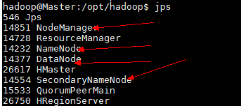

# Spark

1. Version: spark-1.3.1-bin-hadoop2.4
2. Installation directory: /opt/spark
3. Start command:

/opt/spark/spark-1.6.2-bin-hadoop2.6/bin$ spark-shell

1. Background process check

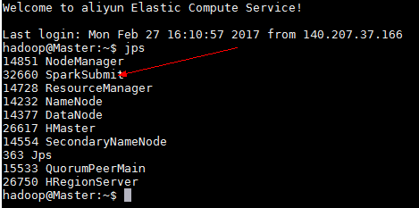

# Hive

1. Version: Hive 2.1.0
2. Installation directory：/opt/hive
3. Start command：

hive --service hiveserver2 > hiveserver2.log 2>&1 &

hive --service metastore > metastore.log 2>&1 &

1. Background process check

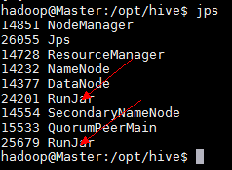

# Hbase

1. Version : HBase 1.2.2
2. Installation directory：/opt/hbase
3. Start commend:
4. Start zookeeper first
5. /opt/hbase/bin$ start-hbase.sh
6. Background process check

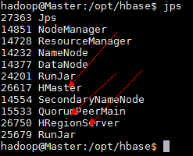

# Zookeeper

1. Version : zookeeper-3.4.9
2. Installation directory：/opt/zookeeper
3. Start commend:

Need to start zookeeper server in all nodes by using below command

/opt/zookeeper/bin$ zkServer.sh start.

1. Background process check

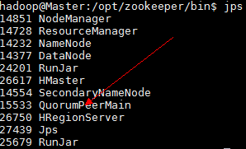

# Hue

1. Version :Hue 3.9.0
2. Installation directory：/usr/local/hue/build/env/bin
3. Start commend: /usr/local/hue/build/env/bin ./supervisor
4. Connect to Hue server with IP address: <http://139.224.10.176:8888/>

For now, only hive and hbase can be used, the other editors need to update the corresponding configuration file.

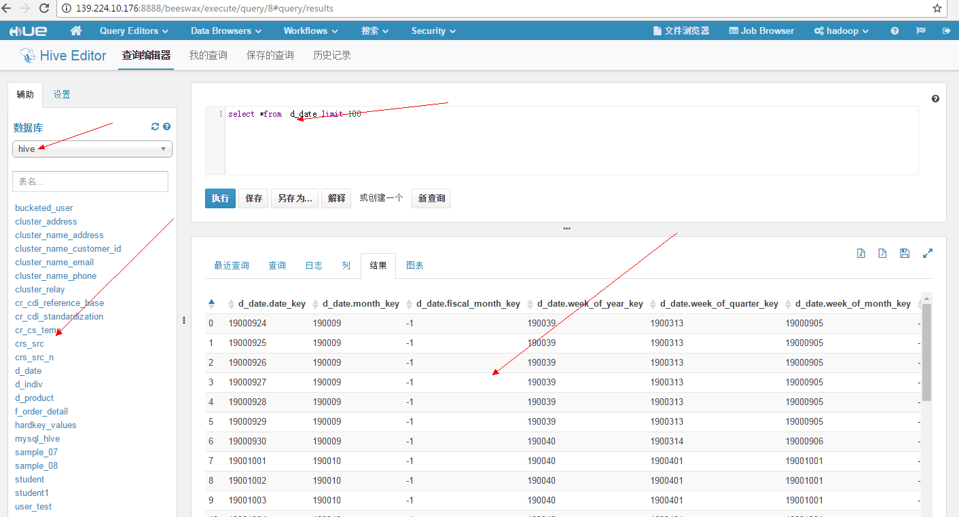

# Sqoop

1. Version : Sqoop 1.4.6
2. Installation directory: /opt/sqoop/
3. Start command:
4. Need to start mysql service first.

(Login: mysql --username hadoop --password mysql)

1. Connect to mysql by using sqoop

sqoop list-databases --connect jdbc:mysql://localhost:3306/sqoop --username hadoop --password mysql

1. Background process check

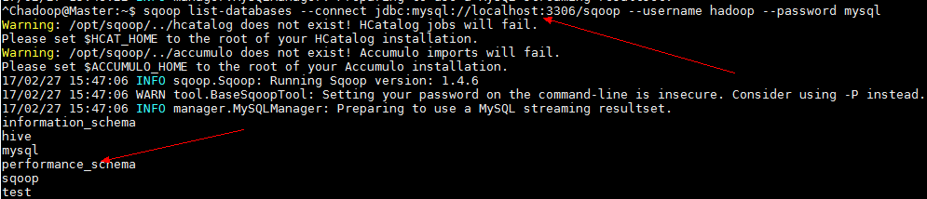

# Kafaka

1. Version:kafka_2.10-0.10.1.0
2. Installation directory: /opt/kafuka/
3. Start command:
4. Need to start zookeeper first
5. /opt/kafuka/bin$ ./kafka-server-start.sh ../config/server.properties
6. Start producer:

./kafka-console-producer.sh --broker-list localhost:9092 --topic test

1. Start consumer:

./kafka-console-consumer.sh --zookeeper master:2181 --topic test --from-beginning

1. Background process check

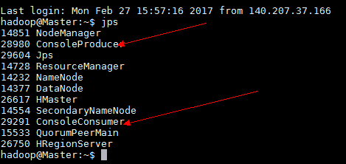

Producer:

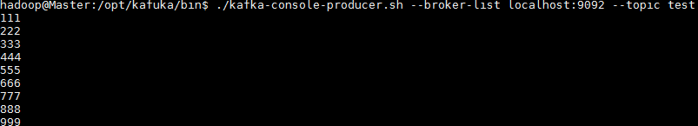

Consumer:

